IUKF Uechi Ryu Euro Workout 2026 – Booking Form
Canterbury Primary School, Canterbury, CT2 8PT ,United Kingdom
Return form via email to : Lee Adams Hanshi Shogun640@gmail.com
11th–13th September 2026
Please complete the booking form below.

SECTION 1 — PERSONAL DETAILS
Full Name:
______________________________________________
Country:
______________________________________________
Association / Club:
______________________________________________
Email Address:
______________________________________________
Grade / Rank:
______________________________________________

SECTION 2 — TRAINING BOOKING
Which training option are you booking?
☐ Full Weekend (£100)
☐ Saturday Only (£50)
☐ Sunday Only (£50)

SECTION 3 — SATURDAY MEAL BOOKING
Will you attend the Saturday evening meal at Bill’s Canterbury?
☐ Yes
☐ No
2 courses - £24.95
3 courses - £28.95

Starter
☐ Seasonal Soup
☐ Crispy Calamari
☐ Halloumi
☐ Crispy Shiitake Mushroom Tostada
☐ King Prawn, Avocado & Tomato Cocktail
☐ Bill’s Chicken & Sesame Dumplings
Main Course
☐ Bill’s Classic Burger
☐ Chicken Schnitzel
☐ Roasted Aubergine Steak
☐ Dirty Vegan Burger
☐ Halloumi Burger
☐ Chargrilled Black Angus Sirloin Steak (+£7 Supplement)
☐ Bill’s Fish Pie
☐ Classic Caesar Salad
☐ Bill’s Mac & Cheese
Dessert
☐ Triple Chocolate Brownie
☐ Chocolate & Salted Caramel Tart
☐ Rhubarb & Custard Tart
☐ Lemon Meringue Pie in a Glass
☐ Ice Creams & Sorbet
☐ Mini Cinnamon Doughnuts
Any allergies the restaurant should know about:
______________________________________________
______________________________________________
______________________________________________

Bill’s Menu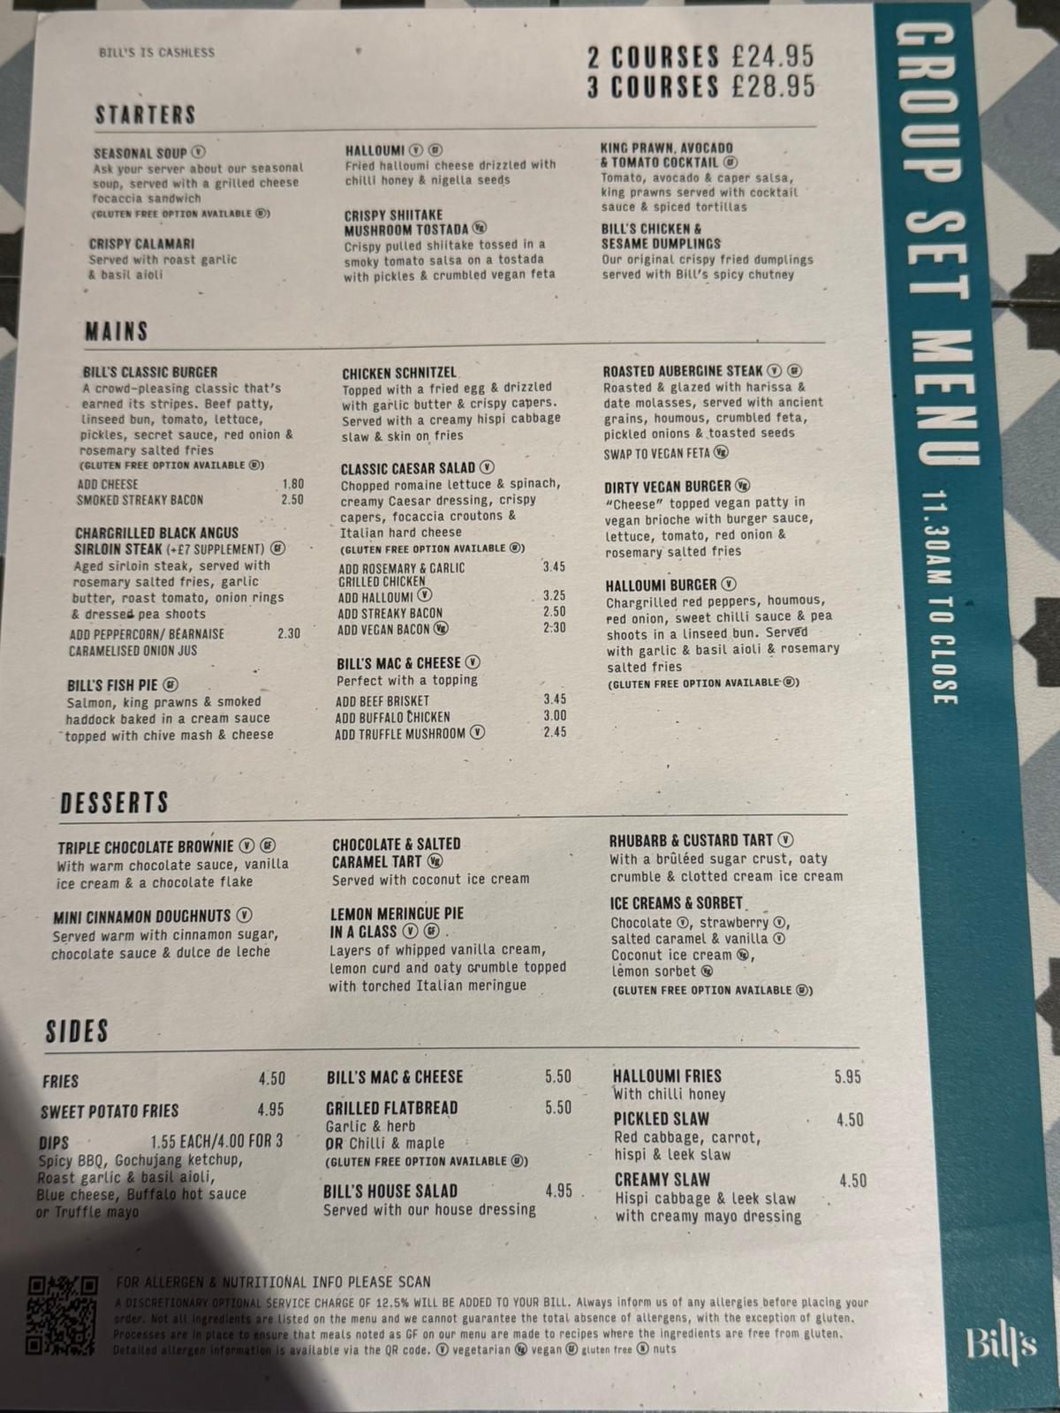
SECTION 4 — PAYMENT
PAYMENT INFORMATION
Please make payment using bank transfer or PayPal (friends and family payment).
Please use YOUR FULL NAME as the payment reference.
BACS Bank Details:-
Mr Lee Adams
National Westminster
Account Number : 13549251
Sort Code :- 60-10-37

Via Paypal (Please pay friends and family)
Shogun640@gmail.com
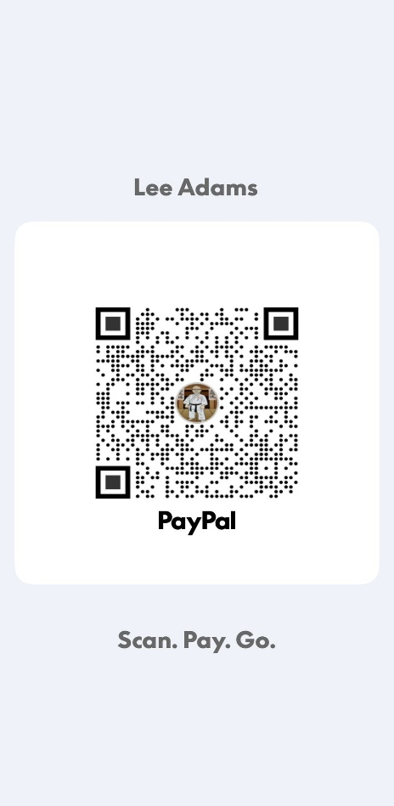
Your booking is confirmed once payment has been received.
Payment Status
☐ Payment Sent

